Which Pet Should I Get?
Hamster
www.livestrong.com/article/197655-facts-about-hamsters-for-kids/
www.angelfire.com/tn/allabouthamsters/basic.html
www.petcha.com/types-of-hamsters/
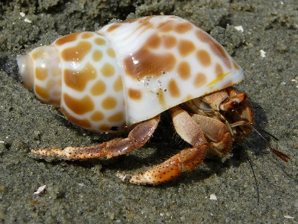 Hermit Crab
http://www.wikihow.com/Care-for-Hermit-Crabs
http://www.hermit-crabs.com/care.html
http://www.petsmart.com/learning-center/fish-care/hermit-crab-care-guide/A0187.html
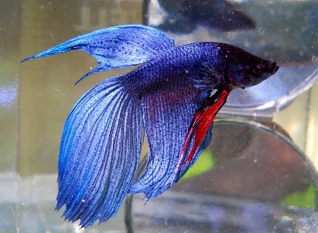 Beta Fish
http://www.petsmart.com/learning-center/fish-care/hermit-crab-care-guide/A0187.html
http://www.instructables.com/id/How-to-Properly-Care-for-a-Betta-Fish/
http://www.wikihow.com/Play-With-Your-Betta-Fish

Why shouldn't I get this pet?
https://www.petakids.com/save-animals/

https://www.petakids.com/photos/hermit-crabs/

https://www.petakids.com/photos/betta-fish/

